Name: __________________________________ Date: 3/7/16 Mr Hood AP Bio [II-Notes]
VIDEO GUIDE BOZEMAN BIOLOGY – NERVOUS SYSTEM http://www.bozemanscience.com/nervous-system
- Why does severing the corpus callosum help some epilepsy patients?
- The base unit of the nervous system is the ___________________
- Neurons send messages through ____________________ ________________
- To cross the gap, or synapse, between neurons ___________________ are used.
- Define each of the following parts of the neuron
Draw and label the parts of a neuron:
    - Dendrite:
    - Axon:
    - Cell body/soma:
    - Myelin:
    - Node of ranvier:

Draw and label the outside/inside of a neuron at resting potential and label the “salty” side vs. “banana” side:
- How is a neuron like a salty banana?

- Why is the outside of a neuron relatively positive?

- If a neuron was a battery, what would be its voltage?

- The flow of sodium ions is like _______________ falling
- After sodium flows into the neuron, the ________________ channels open.
- How is the ion gradient re-established?
- How are action potentials different when the strength of the stimulus changes?
- When the action potential reaches the end of the axon, it causes an influx of ________
- The influx of ___________ causes the release of ____________ across the synapse. Label the diagrams
- How are inhibitory messages and excitatory messages different? 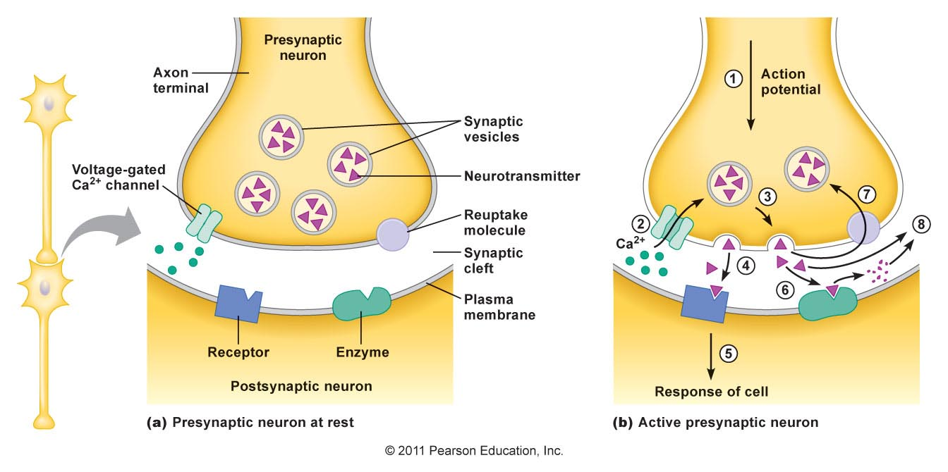

Harvard Nerve Impulse Animation: http://outreach.mcb.harvard.edu/animations/actionpotential_short.swf
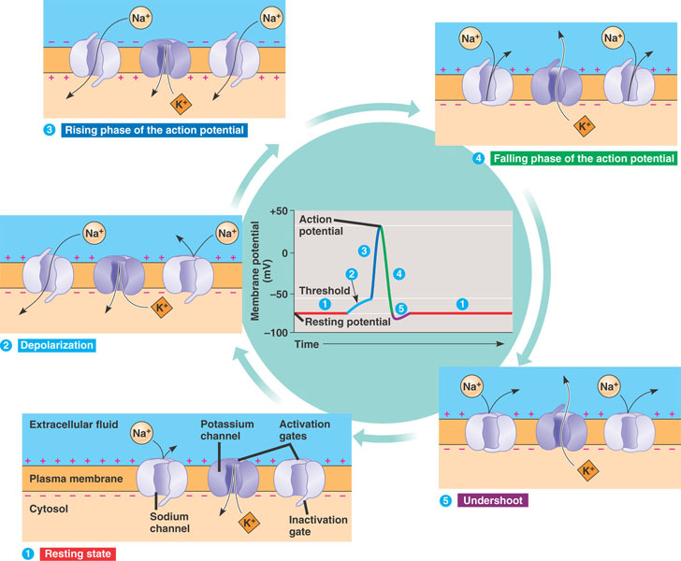
- For each numbered step of the action potential, write what happens/what steps are needed in the Harvard game.
- Write a short FRQ describing the steps of how an action potential is generated. Use and underline the following vocab: nerve impulse, resting potential, axon, neuron, resting potential, threshold, depolarization, repolarization, Na + channel, K+ channel, hyperpolarization, Na+/K+ pump.
____________________________________________________________________________________________________________________________________________________________________________________________________________________________________________________________________________________________________________________________________________________________________________________________________________________________________________________________________________________________________________________________________________________________________________________________________________________________________________________________________________________________________________________________________________________________________________________________________________________________________________________________________________________________________________________________________________________________________________________________________________________________________________________________________________________________________________________________________________________________________________________________________________________________________________________________________________________________________________________________________________________________________

