Name: __________________________________ Date: Mr Hood AP Bio [V-Writing]
Long FRQ Graphing and Photosynthesis Practice
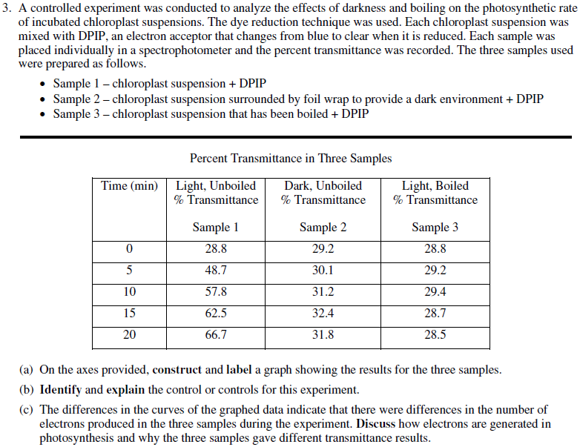

________________________________________________________________________________________________________________________________________________________________________________________________________________________________________________________________________________________________________________________________________________________________________________________________________________________________________________________________________________________________________________________________________________________________________________________________________________________________________________________________________________________________________________________________________________________________________________________________________________________________________________________________________________________________________________________________________________________________________________________________________________________________________________________________________________________________________________________________________________________________________________________________________________________________________________________________________________________________________________________________________________________________________________________________________________________________________________________________________________________________________________________________________________________________________________________________________________________________________________________________________________________________________________________________________________________________________________________________________________________________________________________________________________________________________________________________________________________________________________________________________________________________________________________________________________________________________________________________________________________________________________________________________________________________________________________________________________________________________________________________________________________________________________________________________________________________________________________________________________________________________________________________________________________________________________________________________________________________________________________________________________________________________________________________________________________________________________________________________________________________________
________________________________________________________________________________________________________________________________________________________________________________________________________________________________________________________________________________________________________________________________________________________________________________________________________________________________________________________________________________________________________________________________________________________________________________________________________________________________________________________________________________________________________________________________________________________________________________________________________________________________________________________________________________________________________________________________________________________________________________________________________________________________________________________________________________________________
________________________________________________________________________________________________________________________________________________________________________________________________________________________________________________________________________________________________________________________________________________________________

Name: __________________________________ Date: Mr Hood AP Bio [V-Writing]
Enzyme/Protein/Cell Membrane Structure and Function
Write your response to the questions in the space provided below. Only material written in the space provided will be scored. Answers must be written out in paragraph form. Outline form is not acceptable. Labeled diagrams may be used to supplement discussion, but unless specifically called for by the question, a diagram alone will not get credit.
*Remember: Use the Main point + 3 method*

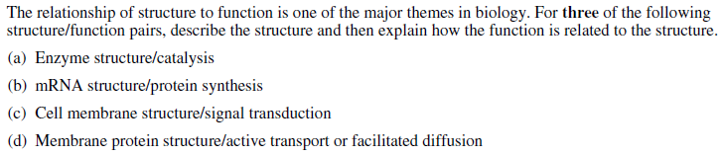
Outline Space:

________________________________________________________________________________________
________________________________________________________________________________________
________________________________________________________________________________________
________________________________________________________________________________________________________________________________________________________________________________________________________________________________________________________________________________________________________________________________________________________________________________________________________________________________________________________________________________________________________________________________________________________________________________________________________________________________________________________________________________________________________________________________________________________________________________________________________________________________________________________________________________________________________________________________________________________________________________________________________________________________________________________________________________________________________________________________________________________________________________________________________________________________________________________________________________________________________________________________________________________________________________________________________________________________________________________________________________________________________________________________________________________________________________________________________________________________________________________________________________________________________________________________________________________________________________________________________________________________________________________________________________________________________________________________________________________________________________________________________________________________________________________________________________________________________________________________________________________________________________________________________________________________________________________________________________________________________________________________________________________________________________________________________________________________________________________________________________________________________________________________________________________________________________________________________________________________________________________________________________________________________________________________________________________________________________________________________________________________________________________________________________________________________________________________________________________________________________________________________________________________________________________________________________________________________________________________________________________________________________________________________________________________________________________________________________________________________________________________________________________________________________________________________________________________________________________________________________________________________________________________________________________________________________________________________________________________________________________________________________________________________________________________________________________________________________________________________________________________________________________________________________________________________________________________________________________________________________________________________________________________________________________________________________________________________________________________________________________________________________________________________________________________________________________________________________________________________________________________________________________________________________________________________________________________________________________________________________________
________________________________________________________________________________________

Name: __________________________________ Date: Mr Hood AP Bio [V-Writing]

Short FRQ Practice—DNA, Variation, Genetic Engineering
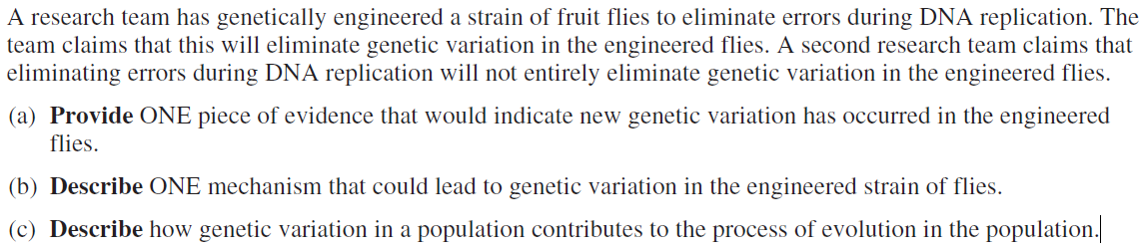

________________________________________________________________________________________________________________________________________________________________________________________________________________________________________________________________________________________________________________________________________________________________________________________________________________________________________________________________________________________________________________________________________________________________________________________________________________________________________________________________________________________________________________________________________________________________________________________________________________________________________________________________________________________________________________________________________________________________________________________________________________________________________________________________________________________________________________________________________________________________________________________________________________________________________________________________________________________________________________________________________________________________________________________________________________________________________________________________________________________________________________________________________________________________________________________________________________________________________________________________________________________________________________________________________________________________________________________________________________________________________________________________________________________________________________________________________________________________________________________________________________________________________________________________________________________________________________________________________________________________________________________________
Name: __________________________________ Date: Mr Hood AP Bio [V-Writing]
Extra FRQ Answer Space

________________________________________________________________________________________________________________________________________________________________________________________________________________________________________________________________________________________________________________________________________________________________________________________________________________________________________________________________________________________________________________________________________________________________________________________________________________________________________________________________________________________________________________________________________________________________________________________________________________________________________________________________________________________________________________________________________________________________________________________________________________________________________________________________________________________________________________________________________________________________________________________________________________________________________________________________________________________________________________________________________________________________________________________________________________________________________________________________________________________________________________________________________________________________________________________________________________________________________________________________________________________________________________________________________________________________________________________________________________________________________________________________________________________________________________________________________________________________________________________________________________________________________________________________________________________________________________________________________________________________________________________________

