**Frog Dissection Pre-Lab** Name:_______________________ Total:_____/ 15 marks [Com]

Full completion of this Dissection Pre-Lab is your license to participate in the Frog Dissection.

Your completed pre-lab worksheet must be handed in at the end of the period.

**Activity 1: Introduction to the Frog Dissection**

**Go to the following website (Surgery Games-Frog Dissection): [5 marks]**

[**http://www.mhhe.com/biosci/genbio/virtual_labs/BL_16/BL_16.html**](http://www.mhhe.com/biosci/genbio/virtual_labs/BL_16/BL_16.html)

**Click on the Screen to begin the game. Follow the directions to dissect the frog and identify key organs. When you are done, answer the following questions:**

1. What was your first step in beginning the dissection? _________________________________________
2. How many cuts did you make to open the frog’s abdomen? ______
3. What tools did you use to cut open the frog? ______________________________
4. 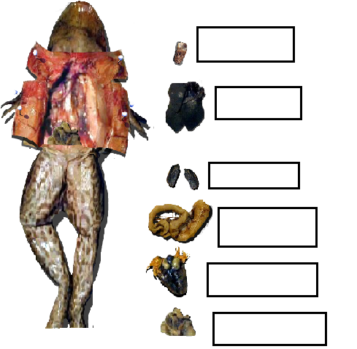Label the organs you identified in the picture below:

**Activity 2: Analysis of the Frog Anatomy**  **[6 marks]**

**Click on the Boreal Digital Dissection icon found on your Applications Desktop.**

**→ Click on the Frog Dissection button → Click on Dissection on the left menu to begin**

1. You will now step through the removal of the frog skin. (We won’t remove the skin in our dissection). Click on the NEXT button to move through STEPS 1 to 13.
2. Step 13 shows how to open the frog’s mouth. Click on the SCISSORS tool and then click on HINT to see where to cut. Watch the video that shows the examination of the frog mouth.

Where is the frog’s tongue attached in the mouth? ________________________________________

How does this compare to the human tongue? ____________________________________________

1. Click on NEXT to move to Step 14. Label the following structures on the diagrams below:

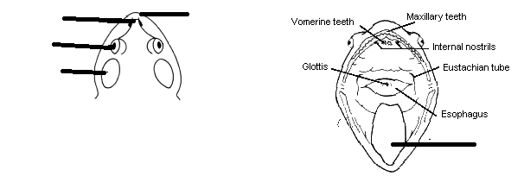 **Eye**

**Tympanum (the Frog’s hearing organ)**

**Nostril**

**Mouth**

**Tongue**

1. Click on NEXT to move to Step 22. Label these structures in the diagram below: **Liver Stomach Fat Bodies**

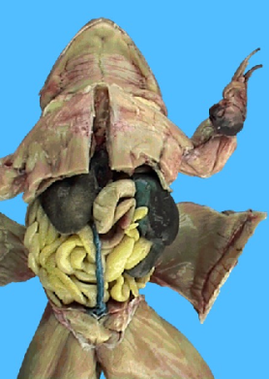

1. Click NEXT to move to Step 25. Label these structures in the close-up view: **Heart Stomach Liver Fat Body**



1. Click NEXT to move to Step 28. The fat bodies, heart and liver have been removed to expose the lungs (small, dark, spongy organs) and the gall bladder (a round sac-like structure). Label these structures below:

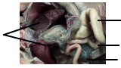**Lungs**

**Gall Bladder**

**Stomach**

**Intestine**

1. Click NEXT to move to the Step 30 (the final step). The stomach and intestines have been removed to expose the kidneys at the back of the abdominal cavity and two small light, bean-like structures (the Testes).

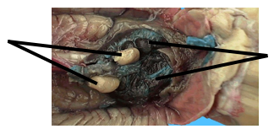 Label these structures on the diagram**: Kidneys Testes**

Is the frog shown male or female? _____________________________

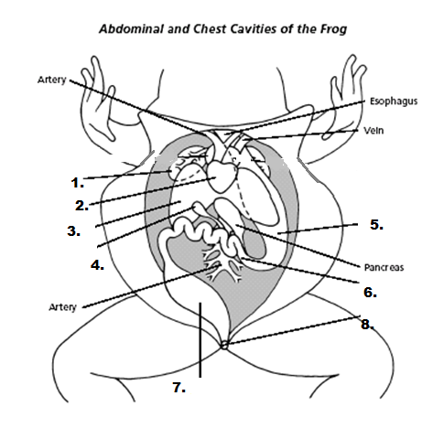**Activity 3**: On the diagram below, label all the indicated organs: **[4 marks]**

**Heart**

**Lung**

**Stomach**

**Gall Bladder**

**Liver**

**Small Intestine**

**Large Intestine**

**Cloaca (similar to the anus**)