Name: ____________________________ Date: 8/29/14 Mr. Hood AP Bio Per: ___
Chapter 3: Water and Life SQ3R Notes Example

Overview: The Molecule That Supports all Life
  - Polar Covalent Bonds in water molecules result in hydrogen bonding

Concept Check 3.1 Qs

  - Four emergent properties of water contribute to Earth’s suitability for life
    - Cohesion of water molecules
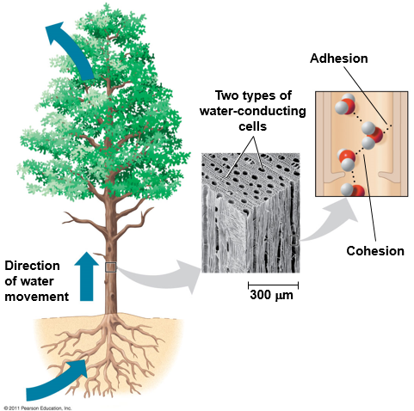
- Cohesion: water molecules are held closely together with hydrogen bonds between ∂+ H and ∂- O sides of different water molecules
- Adhesion: water sticking to another substance (ex. Cell walls of plants)
- Surface tension: how hard it is to stretch/break surface of a liquid
  - Water has very high surface tension due to many hydrogen bonds
  - This allows glass to fill past top and spiders to walk on surface of water
- H-bonds weak and constantly changing
- Water transport in plants: H-bonds help water get pulled up a tree from roots, through water cells, and out leaves. Water evaporating out leaves pulls water below due to cohesion. Adhesion also helps hold water to cell walls and stop it from falling down due to gravity.
    - Moderation of temperature by water
- Water is a heat bank because it holds lots of heat and only changes it’s temperature a little bit
      - Heat & Temperature
- Kinetic energy = energy of motion, how fast particles are moving (random)
- Heat = total kinetic energy due to motion ***depends on volume, so more V = more heat at same T***
- Temperature = average kinetic energy ? is Heat = Temp x Volume ?
- Ice “cools” drink by accepting heat that moves from hotter liquid to ice
- Celsius scale = scientific way to measure temp (0° C (32F) = freezing, 100° C/212F = boiling
- Calorie = heat needed to raise 1g water by 1° C (*Or energy RELEASED when cooling 1° C)
- Kilocalorie = kilo = 1000, so 1000cal, or heat to raise 1kg water 1° C (This is cal on food!)
- Joule (J) = 0.239cal; 1 cal = 4.184 joules
      - Water’s High Specific Heat
- Specific heat = amt. heat absorbed/lost for 1g to change 1° C (how much heat something holds before it changes temperature)
  - Water’s sp. Heat = 1cal/g ·° C, REALLY HIGH compared to other substances
    - Ethyl Alcohol sp heat = 0.6 cal/g ·° C
    - Burn finger on iron pot when water is lukewarm b/c waters sp heat is 10x more, so iron heats up 10x as fast as water
  - Hydrogen bonding causes high sp. Heat of water b/c lots of heat needed to break H-bonds
    - When water heats, most heat breaks h-bonds; when it cools, h-bonds form + release heat
  - How does high sp. Heat support life on earth?
    - Store heat in ocean and release slowly at night/winter to warm coastal areas (L.A.)
    - Water on earth keeps earth temp within narrow range perfect for life
    - Organisms (and us) are mostly water so we don’t heat up/cool down super fast
      - Evaporative Cooling
- vaporization/evaporation = Some molecules move faster than others and turn to gas
- Heat of vaporization = amt. of heat liquid needs to absorb before 1g turns to gas
  - Water has SUPER HIGH h.o.v. too b/c h-bonds have to break before it turns to gas
  - How does this affect life? Moderate global climate
    - Lots of heat absorbed at equator to evap. Water; heat released at poles as water condenses
    - Steam burns = energy released as steam condenses to liquid on skin! Ouch!
- Evaporative cooling = surf. Of liquid cools as hottest molecules evaporate (all fastest runners leave = slower avg. runners)
  - How affect life? Stabilize temp in lakes/ponds + cool organisms
    - Plant leaves cool as water evaporates out
    - Humans cool by sweating and that sweat evaporating and taking heat with it
      - High humidity like RGV sucks b/c sweat can’t evaporate and cool us!
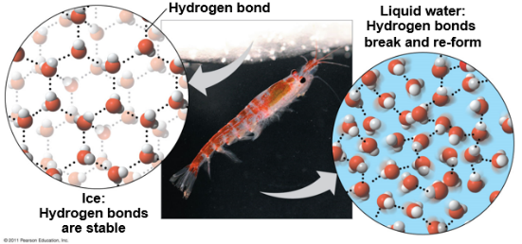
    - Floating of Ice on Liquid Water (Expansion upon freezing)
- Almost all materials become denser when solid, but water gets less dense and ice floats!
- H-bonding causes ice to float
  - At 0°C water mol move too slow to break H-bonds, form crystal structure that spreads H-bonds out “at arms length”, 10% less dense than water
  - In liquid water H-bonds constantly breaking/re-form
- How help life?
  - If ice sank, all ponds/water would eventually freeze solid in winter (top freeze, fall to bot, new top freeze, etc. until all was solid ice). That would kill most everything!
  - Ice insulates water below allowing for fish/shrimp/life under ice
  - Ice is habitat for seals, polar bears, etc.
  - Global warming threatens all life that depends on ice as it melts faster
    - Water: The solvent of Life
- Solution = liquid that’s homogenous (same) mix of 2+ substances (e.g. sugar water)
- Solvent = one that dissolves the other (water); solute = one that is dissolved (sugar)
- Aqueous solution = any solution where water is solvent (abbreviated aq. Solution)
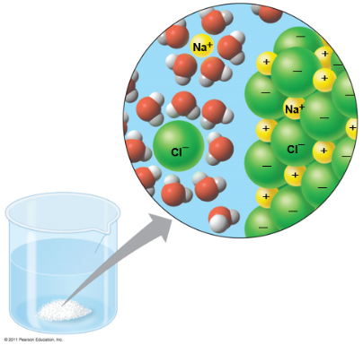
- Water is the best solvent there is (dissolves most variety of things) but not all (e.g. glass, plastic)
- Ex: Water dissolves salt
  - Salt has Na+ and Cl– ions together. Water ∂+ H and ∂- O sides attract to Cl- and Na+ like magnets (opposites attract) and break up ionic bonds, surrounding with water. Eventually all NaCl becomes ionized to Na+ surrounded by water and Cl- surrounded by water.
  - Hydration shell = circle of water molecules that surround each dissolved ion (e.g. Na+)
  - Water can also dissolve non-ionic polar molecules like sugar, proteins, (see diagram)
  - Blood, sap in trees, cytoplasm in cells all aqueous solutions with LIFE
      - Hydrophilic and hydrophobic substances
- Hydrophilic = water loving (attracted to water b/c it has a polar charge)
- Colloid = hydrophilic things too big to dissolve in water (see as fine particles) that stay suspended there
- Cotton is hydrophilic (forms h-bonds w/ water to dry you) but doesn’t dissolve in wash
- Hydrophobic = water fearing (non-ionic, non-polar = won’t H-bond with water
  - Oil is hydrophobic b/c it has non-polar cov. Bonds (C-H) that don’t H-bond
  - Cell membranes (hold in water of cells) made of hydrophobic oils so they don’t dissolve
      - Solute Concentration in Aqueous Solutions
- Bio exp. Involve water, so calc. dissolved solutes
- Molecular mass = total mass of all atoms in a molecule
  - E.x. Sucrose C₁₂H₂₂O₁₁ = 12x12 + 22x1+11X16 (mass of elements) = 342 daltons
- Mole (mol) = 6.02 x 10²³ molecules (avogadro’s #), always same # molecules of anything
  - 6.02 x 10²³ daltons in 1g, so 1 mol sucrose = 342g
- How to make 1L of solution with 1mol sucrose?
  - 342g (1mol) sucrose, add water (while stirring) until dissolved, add water to 1L
  - Molarity = # moles of solute per liter (L) of solution. Common measure of aq. solutions
      - Possible Evolution of Life on Other Planets with Water
- Astrobiologists = look for life on other planets, focus on where there’s WATER
- Mars has ice caps at both poles and ice under surface + water vapor in atms. For frost. ALIENS!

Concept Check 3.2 Qs
- Describe how properties of water contribute to upward mvmt of water in a tree.

Adhesion helps water hold on to the sides of the plant cells and not fall down from gravity and cohesion helps pull water up as water evaporating from the leaves pulls on the whole group of water since they are all hydrogen bonded together, helping it all move up.

  - Acidic and basic conditions affect living organisms
- Acids and Bases

- The pH scale

- Buffers

- Acidification: A Threat to Water Quality

Concept Check 3.3 Qs

